Open Bible Stories
The Transfiguration

0 Introduction

0.1 Key Idea
The story of the transfiguration teaches us about the nature of Christ and the power of his resurrection.

0.2 Creedal Verse
“He is the radiance of the glory of God and the exact imprint of his nature, and he upholds the universe by the word of his power. After making purification for sins, he sat down at the right hand of the Majesty on high.” Hebrews 1:3

0.3 Metanarrative Summary
The eternal God created all things in six days. He made a good and perfect world. He made humans in his image to fill the earth and rule over creation. But humans rebelled against God and ruined God’s creation. God set to restore his world through his promise. God made a covenant with Abraham. He promised to bless all nations through Abraham. God kept his promises across the generations. God provided Abraham with a promised child, Isaac. God gave Isaac a wife, and she bore twins Jacob and Esau. God blessed Jacob and his sons, and the blessing continued to the next generation. God rescued Joseph, one of Jacob’s sons, and used him to rescue his family. God caused his people, the Israelites, to multiply in the land of Egypt; eventually, they became slaves. But God raised up a deliverer, Moses, to deliver his people from slavery. God judged the Egyptians with harsh plagues; in the final judgment, he passed over his people, who covered their doorposts with the blood of a sacrificed lamb. Then, God delivered the Israelites by bringing them out of Egypt and crossing the Red Sea on dry land. God made a covenant with the Israelites and made them his people. God tested Israel in a series of wilderness wanderings and eventually brought his people into the promised land of Canaan. God raised up deliverers to lead Israel and rescue them from their enemies. God formed Israel into a kingdom. He made a covenant with King David and promised to send a king that would rule his people forever. Many of Israel’s kings were evil, and the kingdom of Israel was divided into two kingdoms. God sent prophets to warn his people of God’s judgment and call them to repent. When Israel did not repent, God sent his people into exile. After many years, he brought them back to the land. Throughout the Old Testament, God promised to send his Messiah to deliver his people from their sin. After many years, the prophet John was born. He would prepare people for the coming Messiah. At the perfect time, God sent his Son, Jesus, to be born of a virgin Mary. When John and Jesus grew up, John baptized Jesus as a sign that Jesus was God’s beloved Son. Jesus endured all manner of temptation without ever sinning. When he was thirty years old, he launched a public ministry of preaching, teaching, and healing. He taught his disciples about the life of compassion, sacrifice, and forgiveness. Jesus performed many miracles: he fed a crowd of five thousand, he walked on water, he healed the sick, and he cast out demons. He proclaimed to people the nature of real faith, God’s kingdom, and how fallen humans can be restored in relationship with God. Toward the end of his ministry, Jesus revealed his power and glory to his disciples.

0.4 Open Bible Story: The Transfiguration

36-01
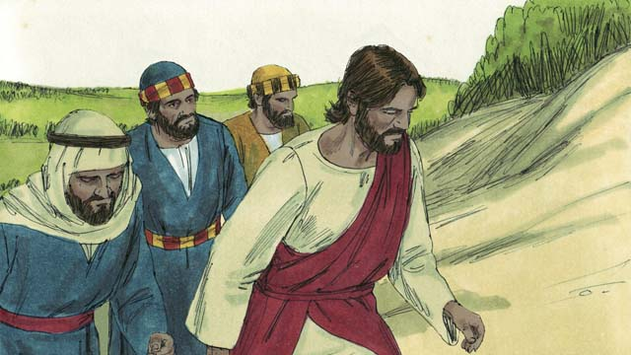
One day, Jesus took three of his disciples, Peter, James, and John, with him. (The disciple named John was not the same person who baptized Jesus.) They went up on a high mountain by themselves to pray.

36-02
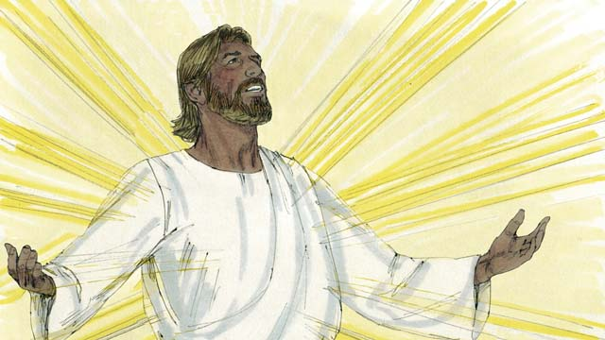
As Jesus was praying, his face became as bright as the sun. His clothes became as white as light, whiter than anyone on earth could make them.

36-03
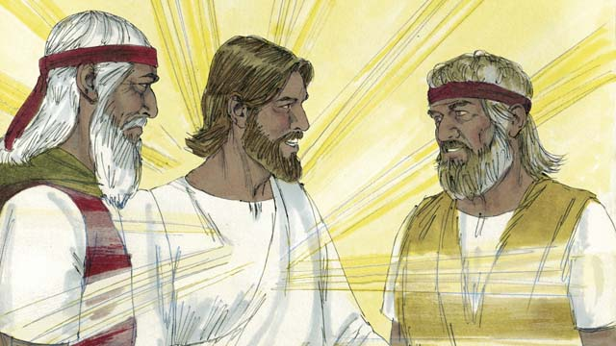
Then Moses and the prophet Elijah appeared. These men had lived on the earth hundreds of years before this. They talked with Jesus about his death because he would soon die in Jerusalem.

36-04
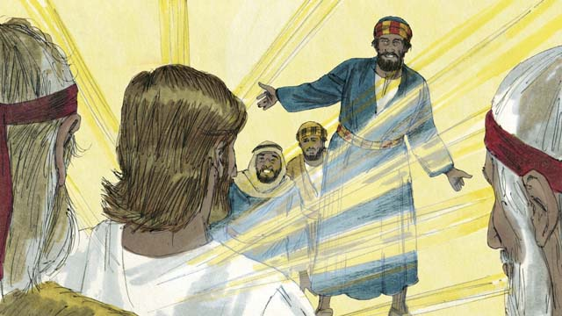
As Moses and Elijah were talking with Jesus, Peter said to Jesus, “It is good for us to be here. Let us make three shelters, one for you, one for Moses, and one for Elijah.” But Peter did not know what he was saying.

36-05
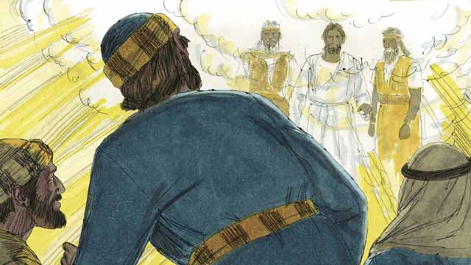
As Peter was talking, a bright cloud came down and surrounded them. Then they heard a voice coming from the cloud. It said, “This is my Son whom I love. I am pleased with him. Listen to him.” The three disciples were terrified and fell to the ground.

36-06
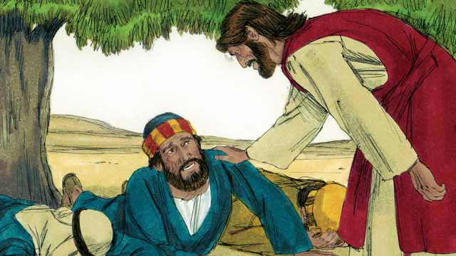
Then Jesus touched them and said, “Do not be afraid. Get up.” When they looked around, the only one still there was Jesus.

36-07
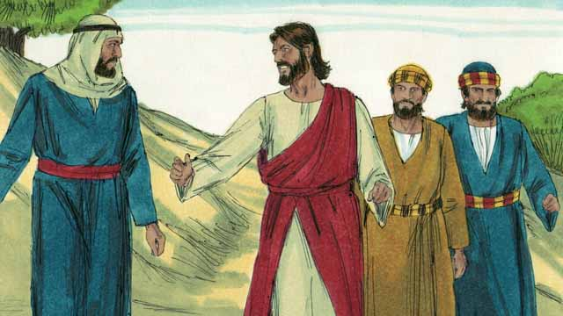
Jesus and the three disciples went back down the mountain. Then Jesus said to them, “Do not tell anyone yet about what happened here. I will soon die and then come back to life. After that, you may tell people.”
A Bible story from: Matthew 17:1-9; Mark 9:2-8; Luke9:28-36

1 Community Study: Paying Attention—Maintaining Focus on God’s Calling
- Key Idea: removing distractions from God’s work
- Key Passage: Hebrews 12:1–3
- Main Session: OBS 36 (The Transfiguration)

1.1 Recite the Creedal Verse (3–5 minutes)
The verse below summarizes the teaching of the current passage. Read the verse out loud as a community. Read it again several times as a group until the whole community can recite it from memory.
14 The Word became flesh and lived among us. We have seen his glory, glory as of the one and only who came from the Father, full of grace and truth. John 1:14
OR
31 Therefore, whether you eat or drink, or whatever you do, do all to the glory of God 1 Corinthians 10:31

1.2 Identify Distractions (5–10 minutes)
We all face distractions that can take our attention away from God’s work. Identify distractions that cause you to lose focus on God’s work. As a community, discuss these distractions together.
I can easily get distracted from God’s work for these reasons…

1.3 Read the Passage (3–5 minutes)
Jesus is the perfect example of remaining focused to accomplish God’s work. He even endured great suffering to accomplish the work of salvation. As a community, read the following Bible passage together to understand how Jesus teaches us to remain focused on God’s work.
1 Therefore, since we are surrounded by such a large cloud of witnesses, let us lay aside every weight and easily entangling sin. Let us patiently run the race that is placed before us. 2 Let us pay attention to Jesus, the founder and perfecter of the faith. For the joy that was placed before him, he endured the cross, despised its shame, and sat down at the right hand of the throne of God. 3 So think about him, the one who has endured such opposition from sinners against himself, so that you do not become weary in your hearts and give up. Hebrews 12:1–3

1.4 Discuss the Passage (10-15 minutes)
God wants us to remove distractions and remain focused on his work. This passage highlights Jesus’ perfect example of doing this. As a community, use the following questions to discuss the teaching of the biblical passage.
- How did Jesus remain focused to accomplish God’s work? How is this an example to us?
- How does this passage call us to stay focused on God’s work?
- What hardships can we expect to face as we focus on God’s work?
- How can your community encourage one another to remain faithful and focused on God’s work? How can your community build rhythms to make sure you encourage each other on a regular basis?

1.5 Encouraging One Another (5 minutes)
Take a moment to encourage another person in your community. Specifically, encourage them to remain focused on God’s work like Jesus.
I want to encourage you to…

1.6 Pray to God (5 minutes)
After encouraging one another, pray for each other that God will supply the encouragement, joy, and focus needed to continue the work together.

1.7 Sing a Song (3–5 minutes)
Choose a song to sing that helps your community celebrate Jesus’ faithful and focused work. Sing this song together as a community.

2 Biblical Interpretation: Observing the Details of the Story
After reading the crafted biblical story, answer the following questions to familiarize yourself with the details of the story.

2.1 Observation Questions
Answer the following observation questions to gain a basic understanding of the story. Read the story as a community and answer these questions as a group.

36-01
Who did Jesus take with him up the mountain?
He took three of his disciples—Peter, James, and John.
Why did Jesus bring them up on the mountain?
They went up on a high mountain by themselves to pray.

36-02
What change happened to Jesus as he was praying?
His face became as bright as the sun, and his clothes became as white as light.
How white did his clothes become?
They became as white as light, whiter than anyone on earth could make them.

36-03
Who were the two men who appeared with Jesus?
Moses and the prophet Elijah appeared.
Why was it miraculous that Moses and Elijah appeared with Jesus?
They both lived hundreds of years before this.
What were Moses and Elijah discussing with Jesus?
They talked about Jesus’ death.
Where was Jesus going to die?
He was going to die in Jerusalem.

36-04
What did Peter think about Moses and Elijah appearing on the mountain?
Peter said it was good that they were there when Moses and Elijah appeared.
What did Peter suggest they do for Jesus, Moses, and Elijah?
He wanted to make three shelters, one for Jesus, one for Moses, and one for Elijah.
What was wrong with what Peter said?
Peter did not really know what he was saying.

36-05
What happened as Peter was talking?
A bright cloud came down and surrounded them, and they heard a voice speak from the cloud.
What did the voice from the bright cloud say to the disciples?
It said, “This is my Son whom I love. I am pleased with him. Listen to him.”
How did the three disciples respond to this voice?
The three disciples were terrified and fell to the ground.

36-06
What did Jesus do to his three disciples?
Jesus touched them, told them not to be afraid, and instructed them to get up.
What did the disciples see when they looked around?
When they looked around, the only one still there was Jesus.

36-07
What did Jesus tell the disciples to do about what they had seen as they went down the mountain?
He told them not to tell anyone about what happened on the mountain until he died and returned to life.
When did Jesus tell his disciples they could speak about what happened on the mountain?
Jesus told his disciples they could speak about what happened on the mountain after Jesus rose from the dead.

2.2 Translation Questions
Use the following translation questions to understand specific details of the passage. Discuss how you might translate these specific elements of the story.

36-01
One day The events of this story actually took place in history. The story does not specify the exact time they occurred. How would you express One day to identify true events that actually took place on an unspecified day and at an unspecified time?

Jesus took three of his disciples Jesus brought his three disciples up on a high mountain to pray. How would you express Jesus took three of his disciples to mean Jesus specifically chose three disciples (Peter, James, and John) to go with him up on a high mountain, and Jesus led them to that place?

James This is a different James than the one who wrote the Book of James in the Bible. How would you express James to mean the disciple of Jesus but not the one who wrote the Book of James in the Bible?

36-02
his face became as bright as the sun At this time, Jesus’ appearance changed. His face became very bright that looked like the brightness of the sun. How would you express his face became as bright as the sun to mean Jesus’ face reflected intense light that was compared to (similar to) the bright shining of the sun?

His clothes became as white as light At this time, Jesus’ appearance changed. His clothes became very white, like the color of light. How would you express His clothes became as white as light to mean Jesus’ clothes changed color and became like the color white which compares to (similar to) the pure color of light?

whiter than anyone on earth could make them Jesus’ clothes turned extremely white. This color is so white that it was more white that people could make their clothes when they bleach them. How would you express whiter than anyone on earth could make them to mean Jesus’ clothes were more white than people could make their clothes white when they bleach them?

36-03
appeared Moses and Elijah were very important people in Israel’s history. God made a covenant with Moses and gave him the law. Elijah was a prophet of God. He spoke God’s messages to people and confronted false gods. They both lived and died hundreds of years ago in past generations. On the mountain, Moses and Elijah showed up out of nowhere. How would you express appeared to mean Elijah and Moses suddenly and unexpectedly were present on the mountain?

because he would soon die in Jerusalem Moses and Elijah spoke with Jesus about the fact that he would die. They spoke with Jesus about this because Jesus’s death would happen in a short time. Specifically, Jesus would die in the city of Jerusalem. How would you express because he would soon die in Jerusalem to mean the reason Moses and Elijah spoke with Jesus about his death was that Jesus would die in Jerusalem in a short time?

36-04
It is good for us to be here It is not clear whether us refers only to Peter, James, and John or if it refers to everyone there, including Jesus, Elijah, and Moses. Peter thought it was positive that they were up on the mountain while these events took place. How would you express It is good for us to be here to mean it was good that they were on the mountain while these events were happening?

shelters Peter wanted to make temporary shelters that functioned like tents or garden huts. Peter thought it was a good idea to build these shelters. These shelters were small, individual, temporary shelters like the Jews made from tree branches during an annual Jewish holiday. How would you express shelters to mean small, temporary dwellings where people could stay for a short time?

did not know what he was saying Peter spoke without thinking clearly because he was so excited about what was happening on the mountain. How would you express did not know what he was saying to mean Peter was speaking without really understanding what was happening?

36-05
a voice coming from the cloud God spoke out loud and the sound of his voice was heard coming from the clouds. How would you express a voice coming from the cloud to mean God spoke and the sound of his voice was heard from the cloud in the sky?

terrified Peter, James, and John were very scared when they heard God speak out loud. How would you express terrified to mean extremely afraid?

fell on the ground The disciples immediately go down on the ground. They did this because they were terrified of the sound of God’s voice. How would you express fell on the ground to mean quickly bowed to the ground as an act of awe and fear?

36-06
touched them Jesus put his hand on the disciples (perhaps on the shoulder). How would you express touched them to mean Jesus placed his hand on the disciples?

Do not be afraid Jesus told the disciples not to fear what was happening. This was a command. How would you express Do not be afraid as a command to stop being afraid?

Get up The disciples were kneeling or laying on the ground, and Jesus instructed them to stand up. How would you express Get up as a command to stand up on one’s feet and stop laying/kneeling on the ground?

the only one still there was Jesus Moses and Elijah left, and Jesus was the only one of the three remaining. The disciples were still on the mountain with Jesus. How would you express the only one still there was Jesus to mean Jesus remained on the mountain after Moses and Elijah left?

36-07
I will soon die and then come back to life Jesus explained that he would die sometime in the near future. After his death, Jesus would become alive again. This is a miracle. Only God can make dead people come back to life. How would you express I will soon die and then come back to life to mean Jesus would die at a time/day that was not too far in the future, and after his death, he would become alive again?

After that, you may tell people Jesus explained to his disciples that they were allowed to tell people about the events on the mountain after Jesus rose from the dead. How would you express After that, you may tell people to mean Jesus permitted his disciples to tell others about what took place on the mountain only subsequent to his resurrection from the dead?

3 Theological Dialogue: Discussing the Meaning of the Story
Take time to explore the meaning of this story together as a community. Use the following discussions to grasp the truth the story teaches.

3.1 Discourse Questions
Use the following discourse questions to understand the meaning of the story. Pay attention to how the story itself addresses each question or theme.

Why did Jesus bring his three disciples up on the mountain? (36-01, 36-02)
Solitude/Be By Themselves: Jesus brought Peter, James, and John up to the mountain. He only brought these three of all his disciples. They went up to the mountain to be by themselves. (36-01)

Prayer: Jesus brought the disciples up on the mountain to pray. Jesus’ appearance changed while he was praying. (36-01, 36-02)

Learning about Jesus: Jesus’ appearance changed to bright light and whiteness. Jesus brought the disciples on the mountain to teach them about himself and what he had come to do. (36-02)

What happened on the mountain that showed who Jesus really is and what he came on earth to do? (36-02, 36-03, 36-05, 36-06, 36-07)
Bright and White: The appearance of Jesus changed. He became bright as the sun and white as light. This showed that Jesus was full of glory and majesty. (36-02)

Jesus as Fulfillment: Moses and Elijah appeared and talked with Jesus. These were important leaders in Israel’s history and faith. Eventually, Moses and Elijah left, and Jesus was the only one of the three left. This highlighted that these important leaders pointed people to Jesus. Jesus is the fulfillment of God’s promises in the Old Testament to send a deliverer. (36-03, 36-06)

Jesus’ Death: Jesus, Moses, and Elijah spoke about the fact that in a short time, Jesus would die in the city of Jerusalem. Jesus would die to save people from their sin. (36-03, 36-07)

Jesus’ Resurrection: Jesus told his disciples that he would come back to life. After Jesus would die in Jerusalem, he would become alive again. In this way, Jesus conquered death and sin. (36-07)

Jesus as God’s Eternal Son: God spoke out loud and explained that Jesus was his Son and he loved him. Jesus is greater than Moses and Elijah. He is God’s eternal Son who is equal to God the Father and deserves worship and praise. (36-05)

How did God the Father and Jesus the Son correct his disciples’ understanding of what was happening on the mountain? (36-04, 36-05, 36-06, 36-07)
Ignorance: Peter did not fully understand what was happening. He acted out of ignorance. He wanted to build three shelters to celebrate the Jewish Feast of Booths. In this way, Peter was treating Jesus similarly to Moses and Elijah. However, Jesus is superior to them. Moses and Elijah were the only human leaders chosen by God. Jesus is God’s eternal Son who came to earth as a human to save humanity. Peter is ignorant of the meaning of what was really happening on the mountain. (36-04)

True Faith: Rightly Understanding Who Jesus Is: God spoke out loud and explained who Jesus is. He said that Jesus is God’s Son and God the Father loved him. God wanted Jesus’ disciples to know who Jesus really is. He is God’s eternal Son who came to earth as a human but has existed for all time. (36-05)

Obedience: God told the disciples to listen to Jesus. God wanted Jesus’ disciples to listen and obey what Jesus told them. Following Jesus as a disciple means obeying what Jesus says. (36-05)

Exclusive Trust: Jesus touched his fearful disciples and told them to stop being afraid and to get up. Only Jesus could calm the fears of the disciples. To follow Jesus is to trust Jesus with our lives. It is important that when Jesus did this, Jesus was the only one who was there. Moses and Elijah had left. Moses and Elijah were important figures in Israel’s faith. However, disciples should not put their trust in these people. The only one that a disciple should put their full confidence and trust in is Jesus. (36-06)

Sharing with Others: Jesus instructed his disciples to wait to tell people about what happened on the mountain until Jesus rose from the dead. Jesus’ resurrection would be the appropriate time to speak about these events to others. God wants disciples of Jesus to speak about Jesus to others and tell them about how his death and resurrection can bring them life. (36-07)

3.2 Theological Questions
Answer the following theology questions as a community. Discuss what truths this story teaches.
- How should we understand who Jesus is and what he came on earth to do? What does Jesus’ transfiguration (i.e., his changing of appearance) tell us about his person and work?
- What does it mean to be a faithful follower of Jesus? How does the disciples’ experience on the mountain teach us about the nature of discipleship?

3.3 Translation Draft
Work as a translation team to draft each panel of this story. Pay attention to any specific translation issues that are challenging or significant.

Make Translation Draft
Make a draft for each section of this story.

Discuss and Revise
After drafting the story, discuss any translation issues that you think need a special explanation.

Drafting Summary Reflection
Summarize any noteworthy translation decisions and the rationale/reasoning behind these translation decisions. In the final movement of this class, you will use these observations to give an account (i.e., chronicle/narrate) of how your translation improved through the checking process.

4 Personal Reflection: Following the Teaching of the Story
Take a moment to allow this story to evaluate your own life and to consider how God would have you respond. After this reflection, use the quality checking questions to check your translation draft among the translation team.

4.1 Journal Reflection
Prayerfully think about the following personal reflection questions. Write/Record your answers and/or discuss them as a group.
- When have you experienced meaningful times of prayer when you felt close to God and God’s people?
- How do you think you would have responded if you saw the events up on the mountain?
- What misunderstandings of Jesus need to be corrected in your own belief/thinking?
- In what ways does this story help you more faithfully follow Jesus?

4.2 Team Check
The following activity will help you check the clarity, accuracy, and naturalness of your draft. Read the passage aloud and discuss the checking questions with other members of your translation community. You might need to reread portions (or the whole) of the biblical passage multiple times as you answer each of these questions. Record answers to these questions below.

Team Checking Questions
Use the following questions to check your translation draft for accuracy, clarity, and naturalness.
- Accurate: Has anything been added to your translation of this passage that is not a part of the meaning of the source text? If additions exist, are they only added to clarify meaning (such as implied information)?
- Accurate: Is anything missing from your translation of this passage that is a part of the meaning of the source text? If some part of the meaning is missing from your translation, add it.
- Accurate: Does any meaning in your translation of this passage appear to be different than the meaning of the source text? If the meaning is different, try changing your translation so that the meaning remains the same.
- Natural: Does anything sound unnatural to how you would say it in your language? If portions of the passage sound unnatural in your language, try to make them sound the way you would say them in your language while staying true to the meaning of the source text.
- Clear: Is anything unclear or confusing in your translation that confuses the meaning of the source text? If portions of the passage are unclear or confusing, revise them to clearly communicate the meaning of the source text.
- Consistent: How consistent is your translation within the passage and with other passages? If portions of the passage need to be made consistent or if you need to revise translations of other passages, make these adjustments.

Record Feedback
After discussing the checking questions above as a translation community, record any feedback on your translation draft. Pay attention to parts of your translation that are translated well and parts of your translation that need correction.

Discuss and Revise
After gathering feedback on your draft, discuss it together with your translation community and make appropriate revisions to your translation.

Record Translation Decisions
As a community, discuss some of the most noteworthy translation decisions in your draft. Summarize each decision and explain the reasons your community decided on that translation. You should update these decisions each time you check your draft with various groups of people.
You should measure the quality of your translation draft. You can record translation decisions to make it clear why you translated things a certain way. Translation decisions can help your translation team and the surrounding community be a part of the translation process.
How can you know the quality of your translation?
- Measure the translation by marks/standards of quality (i.e., clear, accurate, natural, church-approved)
- Test the translation with others and record feedback and conversations from in the field (i.e., church and community check)
- Compare and contrast the translation with the source text (i.e., meaning of text and notes) and alternatives (i.e., other translation choices)
- Explain the reasons why you translated a particular portion of the text.
Example Sentences That Help Explain Your Translation Decision Use the following example sentences to help explain your translation decisions:
- The original text literally says/means, so we translated the term in this way…
- We originally decided to translate the biblical term with this term, but we changed it because…
- When our translation team discussed the biblical term, this is what we talked about…
- The term is [clear, accurate, natural, consistent] because…
- The community understands this term to mean…
- We considered these other terms. We did not use these terms because…
- When we checked this in the church, we learned…
- When we checked this in the community, we learned…
Example of Translation Decision
In OBS 01-07 we decided to translate blessed like this: [actual translation]. We decided on this translation because of these reasons:
- The word [actual translation] means to cause good things to happen to someone or something. This term is used when a person desires someone or something to prosper or flourish. This term does not refer to magic or witchcraft.
- When we checked this word with other believers, they said it describes God showing his kindness and favor on someone or something. These are some of the terms that we did not decide to use…
- Many of our people will understand this word. When we discussed this phrase with the surrounding community, we discovered it was a natural way to describe God causing good and beneficial things to happen.

5 Ministry Practice: Serving the Church with the Story
Now that you have a draft of this story, consider how this story can encourage other believers in their faith. After ministering this story to others, you will also perform a community check of your translation draft.

5.1 Church Ministry
Reflect on how this story can edify and mature the Christian community. Design a way to minister this story to your church community.
Ministry Preparation: Take time to consider how you could minister this story to others. Record some ministry ideas below.
Ministry Implementation: Minister this story to a group of believers as you had planned. Use the information in this study to help develop a teaching/lesson or lead a discussion of this story with other believers. Record your ministry plan below.
Ministry Reflection: Think about what you learned from ministering this story to other believers. Reflect on your experience below.

5.2 Church Community Check
After teaching or ministering this story to the church, check the translation quality with the church community. Record any feedback from your checking experience.

Create Checking Questions
You can use Translation Questions to check your draft. Each Translation Question explains the meaning of a specific part of the story and asks you to consider how you would translate that part of the story in your own language. Change each Translation Question into a Checking Question by asking the following questions. The first question asks you to identify how each specific phrase was translated into your language. The second question asks people in the church to determine if your translation of the phrase expresses the meaning clearly, accurately, and naturally. Look at the following examples to see how to change Translation Questions into Checking Questions:

Translation Question Example 1
to proclaim the good news about Jesus Paul and Silas traveled to Philippi for the purpose of preaching the gospel. The gospel is the good news that Jesus saves people from their sins if they will believe in Jesus. How would you express to proclaim the good news about Jesus to mean to tell other people the message about how Jesus can save people from their sins?

Translation Question Example 2
a merchant Paul and Silas met a woman named Lydia at the place by the river. She owned a business and sold items to make money. How would you express a merchant to mean a business owner who sells items for a profit?

Translation Question Example 3
so Paul and Silas baptized them The jailer and his whole family followed Paul’s instructions. They believed in Jesus. The result of this was Paul and Silas baptized them. How would you express so Paul and Silas baptized them to mean the result of the jailer and his family believing in Jesus that Paul and Silas baptized all of them?
You can change these into Checking Questions like this:

Checking Question Example 1
to proclaim the good news about Jesus How did you translate to proclaim the good news about Jesus? Does it mean to tell other people the message about how Jesus can save people from their sins?

Checking Question Example 2
a merchant How did you translate a merchant? Does it mean a business owner who sells items for a profit?

Checking Question Example 3
so Paul and Silas baptized them How did you translate so Paul and Silas baptized them? Does it mean the result of the jailer and his family believing in Jesus that Paul and Silas baptized all of them?

Record Feedback
Discuss the Checking Questions with your church community, and record any feedback on your translation draft. Pay attention to parts of your translation that are translated well and parts of your translation that need correction.

Discuss and Revise
After gathering feedback on your draft, discuss it together with your translation community and make appropriate revisions to your translation.

Record Translation Decisions
*Update your translation decisions and record any new and noteworthy observations on the quality of your draft.

6 Missional Outreach: Sharing the Truth of the Story
After sharing this story with others, check the translation quality with the wider language community. Record any feedback from your checking experience.

6.1 Mission Engagement
Consider how you will witness this story to unbelievers. Design a way to share this story and engage them in what it teaches about Christianity and the gospel.
Witness Preparation: Take time to consider how you will witness this narrative to unbelievers. Record some ideas below.
Witness Implementation: Share this story with an unbeliever. Use the information in this study to help develop a teaching/lesson or lead a discussion of this story with other believers. Record your ministry plan below.
Witness Reflection: Think about what you learned from ministering this story to unbelievers. Reflect on your experience below.

6.2 Sociolinguistic Check
After sharing this story with the language community, check your translation draft with the surrounding community. Record your observations.

Checking Approach
After witnessing this story to unbelievers, use one of the following methods to check the translation of this story. Consider using the Observation Questions to check your translation draft or come up with your own quality checking questions.
Read-Retell Check: Read your draft to those in the community and ask them to retell the passage. Be attentive to any portions of the passage that are unclear, unnatural, or inaccurate.
Comprehension Questions Checklist: Read the draft of the passage and ask a list of comprehension questions to make sure the passage is being rightly understood. You can use the Observation Questions in this guide or come up with your own questions. Then, record any insights or issues that arise.
Discussion Group: Develop key questions to ask about the passage (both formational and translational). Read the passage and have a group discussion about the passage, paying attention to issues that need to be addressed, edited, and revised.

Record Feedback
After sharing your draft with the language community, discuss the Observations Questions, and record any feedback on your translation draft. Pay attention to parts of your translation that are translated well and parts of your translation that need correction.

Discuss and Revise
After gathering feedback on your draft, discuss it together with your translation community and make appropriate revisions to your translation.

Record Translation Decisions
*Update your translation decisions and record and new any noteworthy observations on the quality of your draft.

7 Conclusion
As a translation community, take time to reflect on all that was learned in studying, drafting, and checking this story. Celebrate all that God has taught you as a community. Then, submit your revised draft and checking summaries to network leaders for further review.

